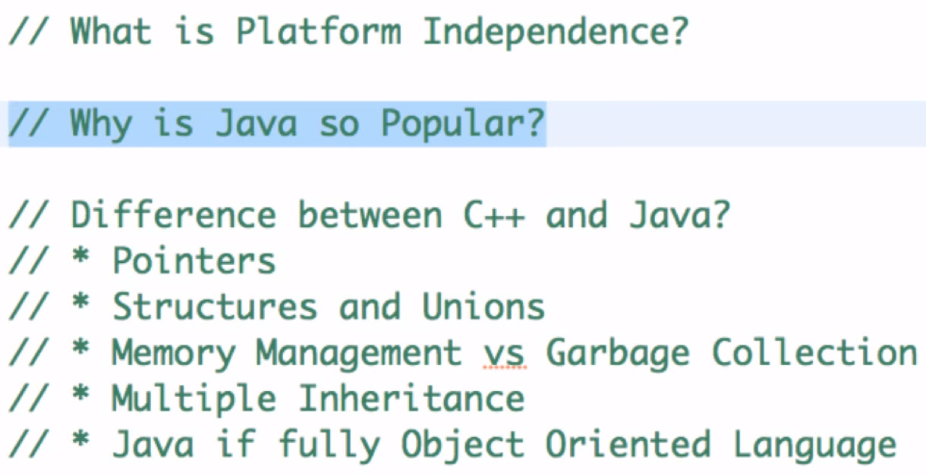
JVM

Platform independent
Pure Object oriented easy to maintain

Pointers: reference to special value in store memory. The address is called a pointer.
Structures and Unions Class(structure and method) and Objects

C++ Dynamic allocate memory ;
Java automate and garbage collections

Multiple inheritance
Pure objective oriented programming.

Encapsulation
Abstraction
Inheritance
Polymorphism
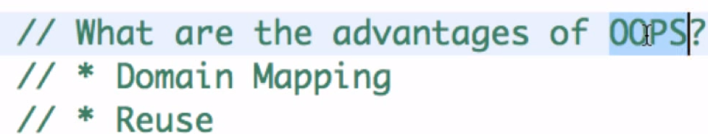

Reuse

Java is fully Passed by value or Pass by reference
String builder is not synchronized
Static and instance
An static variable is shared by all instance of the class.

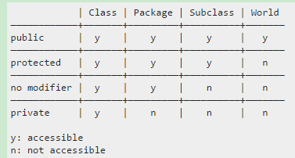

An abstract class, in contrast, provides more structure. It usually defines some default implementations and provides some tools useful for a full implementation.

extends is for extending a class.
implements is for implementing an interface
Immutable class
In object-oriented and functional programming, an immutable object is an object whose state cannot be modified after it is created. This is in contrast to a mutable object, which can be modified after it is created.
An object is considered immutable if its state cannot change after it is constructed. Maximum reliance on immutable objects is widely accepted as a sound strategy for creating simple, reliable code.
Immutable objects are particularly useful in concurrent applications. Since they cannot change state, they cannot be corrupted by thread interference or observed in an inconsistent state.

Inline functions are not always important, but it is good to understand them. The basic idea is to save time at a cost in space. Inline functions are a lot like a placeholder
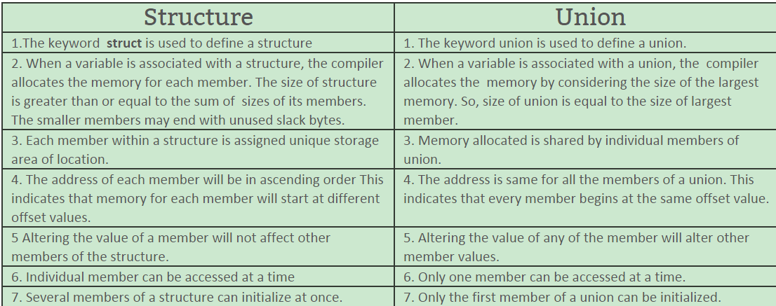
With a union, you're only supposed to use one of the elements, because they're all stored at the same spot. This makes it useful when you want to store something that could be one of several types. A structure, on the other hand, has a separate memory location for each of its elements and they all can be used at once.

Override and overload
Calloc() and malloc()
calloc() zero-initializes the buffer, while malloc() leaves the memory uninitialized.
